**Living Sustainably**

**Main Action Parish Audit** We looked at many areas of the Parish in which more eco-friendly alternatives could be put into place, as well as ways in which our way of working could be altered to be increasingly in keeping with the solidarity aspect of Live Simply. This was achieved through many changes. For example, it was discovered that the office did not have any recycling facilities for paper. In an office environment, this can clearly have a large impact. These are now in place. Also, letters which were previously sent out to hundreds of families for the Sacramental preparation are now sent electronically. Furthermore, in being in solidarity with those who deserve fair wages for their work, we changed many of the Parish tea/coffee/biscuits to Fairtrade.

**Other Action 1 Re-gifting Scheme:** The Parish has continued its popular re-gifting scheme for the Nugent, (started in 2017). This involves people sending in any extra/unneeded Christmas presents so that they could be used to raise money for the great work the Nugent does. (See newsletter insert below)

**Re-Gifting for Nugent** – message from Fr Michael

“No-one receives an unwanted gift or Christmas present but at this time of year it is possible that we find ourselves with Christmas gifts that we are unable to use or have too many. (If I am being honest once or twice in the past, I have opened a gift and wondered why on earth someone thought I would like it or use it!) One solution is to "Re-Gift" them to Nugent, our Archdiocesan caring service. These items are then used as gifts within the various projects, raffle prizes by our fundraising team or sold in our charity shop to directly raise much need funds.

There are boxes at the back of each of the churches for you to place any items to be regifted such as toiletry sets, home wares, clothing, DVDs, food and chocolates within sell by dates or in short anything given that can continue the care and joy of Christmas at Nugent. Indeed, the charity shop is always in need of good quality items to sell so if you have any books, DVDs, good quality clothing or any other items suitable for resale please place them in the boxes too.

Thank you in advance.”

***By establishing this ‘Christmas re-gifting’ initiative we have found that parishioners now continue to recycle a wide variety of clothing and household items etc throughout the year to support the work of Nugent.***

**Other Action 2; Creation Time Talks/Reflections and Lenten Reflections** (Raising Awareness/Discussion/Action)

**Newsletter insert from September 2017:** ‘Creation Time’ ‘Reflections during Creation Time’ is a new resource from CAFOD and the Justice and Peace Commission that uses Sunday Gospels and excerpts from ‘Laudato Si’ to reflect on our world. There is a session for each week of ‘Creation Time’ (Week beginning September 4th to week beginning October 2nd). If you would like a copy of the resource to use as a family; with friends; as a parish group e.g. SVP, UCM, Prayer Group please contact the Parish Office. The Bible Group have started to use the resource at their usual Monday morning session, 10:00 -11:00am; all are welcome to join.

***These resources were used very successfully by the Bible Group and by the RCIA Group as part of their journey of faith exploring ‘faith in action – how our faith can impact on our everyday life choices’ both during ‘Creation Time’ and Lent. They have continued to be used each year as they have been released in 2018/2019.***

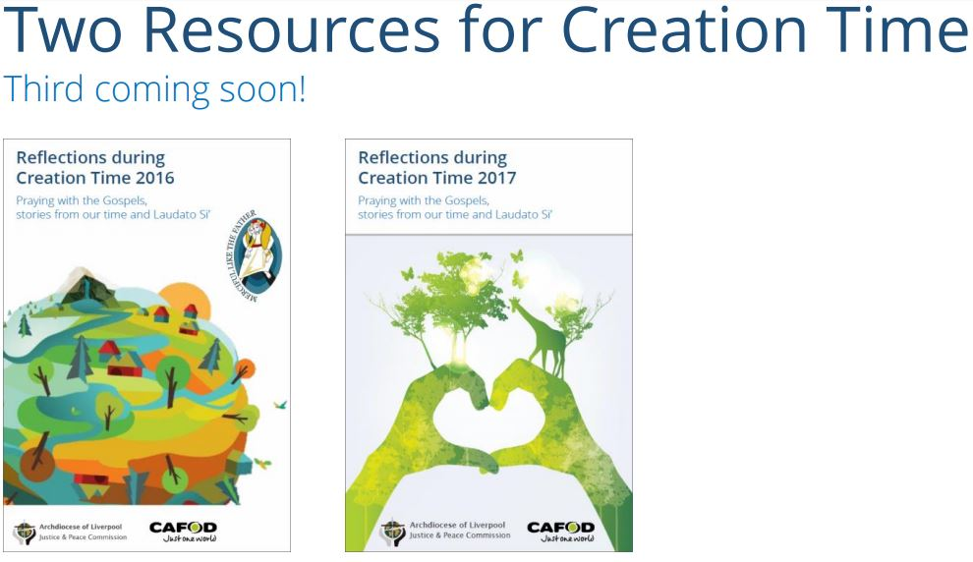

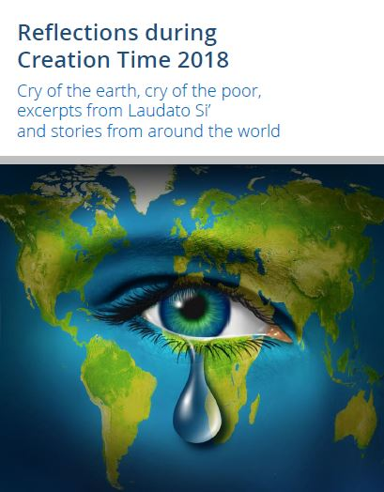

**Two Resources for Lenten Reflection**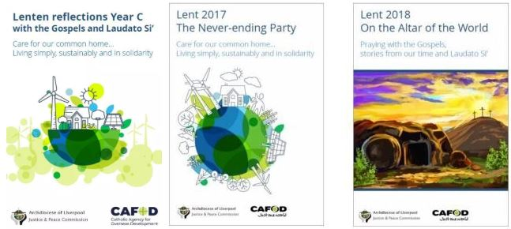

**June 2019 Eco- Talk; Creation Service and Scones night**!

Forty-six people attended the event which encompassed a ‘Creation Service’; A ‘Climate Quiz’ and sharing of good conversation and Scones!

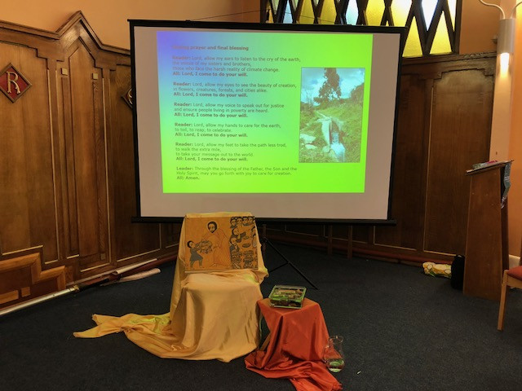

The event started with Fr. Mike leading a Creation Service, which included a presentation of his experience and CAFOD’s work in Ethiopia.

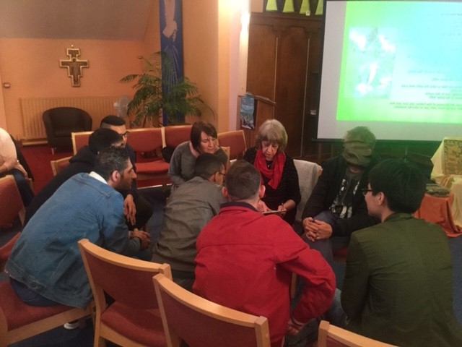

The service was followed by an enjoyable and very competitive Climate Quiz …. which made us all reflect about the impact our everyday lives have on our environment.

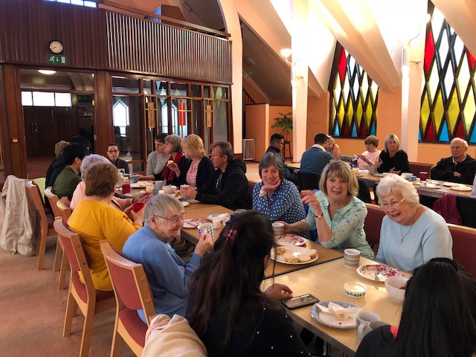

The evening concluded with everybody gathering to chat about all they had heard and to share delicious scones to celebrate the ‘Fruits of Creation’!

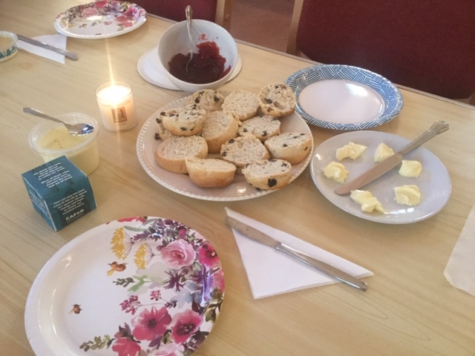

*CAFOD Climate change dice used as discussion aid and prayer to share.

***This little dice, used as part of the evening, is strongly symbolic of developing community relationships and friendships which define part of our Livesimply journey… (it was prepared by one of our new office volunteers who is a client at a Medaille Trust safe house…. He and his friends enjoyed participating in the evening, along with their house staff.)***