**Living in Solidarity**

**Main Action: Supporting the work of Medaille Trust**

Below and attached are a variety of newsletter inserts; comments; pictures; prayers cards; information cards; samples of quarterly magazine, which evidence the developing partnership, bond and friendship between the Parish and the Medaille Trust Mersey Service.

* **Mass celebrating feast day of St Josephine Bakhita, visiting speaker Richard Owens, (Annual Solidarity Talk)** This created awareness among the attendees of the work of the charity, the reality of the human trafficking and modern slavery problems in this country.
* **Diocesan Prayer cards distributed, at the above named Mass, and at weekend Masses February 2017** (See Attached samples)
* **Talk given by Safe House Staff enabling an understanding of the day to day life within the Safe House 2017** (See attached samples of cards which were distributed entitled ‘What to look for’ these were also made available at the weekend Masses following this talk.)
* **Sale of Medaille Charity Christmas cards and Christmas handcrafted goods at Christmas event** (see more details in Living Simply section)
* **Distribution of Medaille Trust Quarterly Magazine to keep Parish informed of the work** (Sample attached)

**Christmas Tree Project 2018/ Christmas Meal 2018**

**Christmas Gifts** (Newsletter Inserts November/December 2018)



At this time of year, we are all very busy planning our Christmas festivities, celebrating with family and friends, giving and receiving gifts and deciding if the turkey will fit in the oven!

**As a parish we are invited to take a few moments to think about how we may be able to support the work of the Medaille Trust this Christmas by giving a present to a victim of human trafficking and modern slavery.**

From the beginning of December, you will see a small Christmas tree at the back of each of our four churches.

1. Take a label from the tree.
2. Buy the gift on the label.
3. Wrap the present.
4. Put the label you took off the tree onto the present you have bought.
5. Return the present to the box near the Medaille Tree in any of our churches by December 16th (3rd Sunday of Advent).

Please take a copy of the Medaille Winter 2018 magazine to see what they have been busy working to achieve over the last few months.

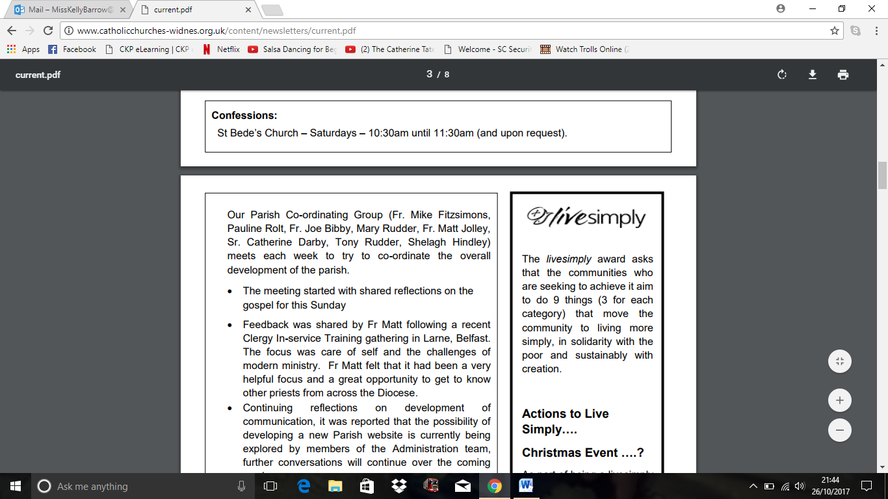

“I would like to send a big thank-you to everyone who has donated a Christmas gift to the Medaille Trust for the victims of trafficking who we support.

What a fabulous surprise it was to see how many kind and generous people we have in our local communities.

The clients we support will have a wonderful Christmas and receive some lovely gifts.

Many thanks and lots of Christmas wishes to you all.”

Sharon Marsh (***Service Manager*** ***the Medaille Trust)***

**Medaille Trust Partnership** [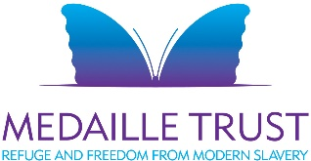](http://www.medaille-trust.org.uk/)

You will have noticed the thank you from Sharon Marsh from the Medaille Trust (Mersey Project) for all the Christmas presents you brought for their residents who all have recent experience of human trafficking. So many gifts came in that we were able to send presents to the neighbouring project in Manchester to spread the reach of our Christmas cheer.

As well as this a good number of residents from the local project attended our Carol Service and Midnight Mass and they really enjoyed joining in. **Also a few parishioners, under the banner of our Welcome the Stranger initiative, organised a festive meal for the residents between Christmas and New Year which we hosted at the Pastoral Centre**. All of these created a wonderful and genuine sense of hospitality, care and welcome in our parish. Given the nature of the needs of the residents and the need for high levels of privacy and protection some of this work was undertaken simply and quietly but in reality, was supported by the whole of our parish community.

The support we offer can often start with charity but also move and change us towards genuine engagement and support. This year has marked a growing relationship with Medaille and the local project and we look forward to this continuing to develop and deepen this coming year.

**Conversational English Sessions 2019**

A further initiative developed in spring 2019 as a result of our parish Pastoral Associate and a parishioner attending training sessions, at Asylum Link Merseyside, in how to support people with English as a second language. Following the training a group formed, after consultation with Medaille Mersey Services Safe House, to offer conversational English sessions.

The first set of six were offered in May 2019, the following feedback was received from some of the clients at the end of the course;

***‘This has been my first ever English class and I know I***

***still have a lot to learn but everyone has been so helpful and done***

***lots to assist me and really help me learn. Thank You.’***

***‘You did a great job nothing needs to be improved.’***

***‘I enjoyed learning numbers. You did a really good job and I would like to be there again if you do more.’***

***‘Very good, no changes, keep doing what you do. Thank you.’***

Amanda (Modern Slavery Support Worker, Mersey Services) said:

***‘From my point of view, I have seen real improvement in clients’ English and those who don’t really speak any English have been making a huge effort since going to your classes. I can see their confidence growing one word at a time and it’s really lovely to hear them using the language. Thanks for doing such a great job.’***

August 2019: The group are now running the second set of sessions ….

**Other Action 1: Supporting and Raising Awareness of the life of St. Oscar Romero and the work of the ‘Romero Trust’**

**First Event; organised and held in the Parish October 2017, (see newsletter insert below)**

Come and watch a new play about Blessed Oscar Romero by www.risetheatre.co.uk ‘Romero – Heartbeat of El Salvador’ at St Wilfrid’s Pastoral Centre, Mayfield Avenue, Widnes, WA8 8PR on Tuesday 10th October at 7:30pm. The production tells the true story of Blessed Oscar Romero and his heart for the oppressed people of El Salvador. Romero chose to challenge those in power and stand up for social justice. He demanded respect for human rights. If you would like to order a ticket please contact the Parish Office – we will make a block booking. Ticket prices are £7.50 for adults and £5 for Years 7 - 11 Performance lasts approximately 75 minutes. (Not suitable for primary age children.)

***This event was attended by a large group of parishioners from St Wilfrid’s and from across the Archdiocese, (approx. 100 plus) including some high school groups. It provided a creative way for people to hear the ‘story’ of Oscar Romero, relate to the concept of what ‘in solidarity’ can really mean… and consider how we are each called to be ‘a voice…of the voiceless’***

**Developing an on-going link of solidarity: ‘Baptism Cross of Welcome’**

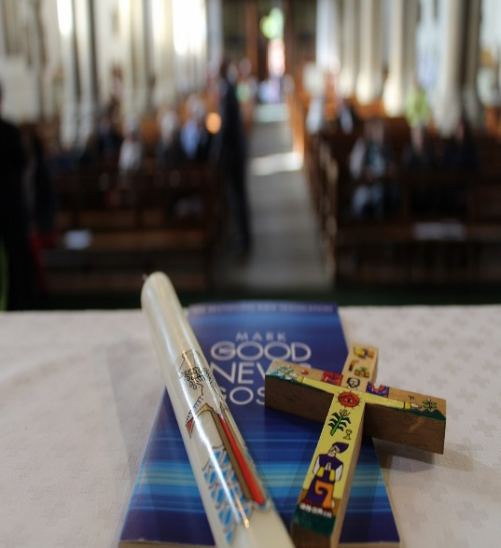As part of our Baptism process we invite families to attend a Mass of Welcome with their child/children. The families are presented with a ‘El Salvador Romero Cross’ to display as Christian symbols in their home.

The purchasing of the crosses, as a Parish, is a further sign of our on-going support of the Romero Trust and the people of El Salvador.

**(Words used at the Mass of Welcome)**

**Presentation of Gospel of Mark and Children’s Cross**

*Each family is presented with a Gospel of Mark and an El Salvador Cross.*

“Receive this gospel and cross as a pledge of our support for you in your vocation, as the first and most important teachers of your children in the ways of faith. May God’s Word, help you and your family to grow in faith, in hope and in love. Enshrine these Christian symbols in your home, so that they may be a source of joy, of strength and of comfort now and for ever. And may the blessing of God the Father and of the Son, and of the Holy Spirit be with you always. Amen.”

**Second Romero Trust event: This was organised and held in the Parish Pastoral Centre on July 9th 2019**

* **See newsletter insert**
* **See flyer, sent out to be advertised across the Archdiocese via CAFOD Liverpool**
* **See photographic evidence**

**Film about St Oscar Romero**

The Archdiocese of Liverpool is delighted to announce the release of a new film documentary about St Oscar Romero entitled:

**Righting the Wrong**

There will be a special presentation by Julian Filochowski of the Romero Trust ([www.romerotrust.org.uk](http://www.romerotrust.org.uk))

**on Tuesday 9th July** **7:00pm – 9:00pm**

**in the Pastoral Centre, Mayfield Avenue, WA8 8PR**

This 80-minute documentary provides an excellent overview of St Oscar Romero’s life and martyrdom in 1980.  He defended the fundamental rights of the people of El Salvador. It goes on to describe the process after his death leading to his canonisation by Pope Francis in October 2018.

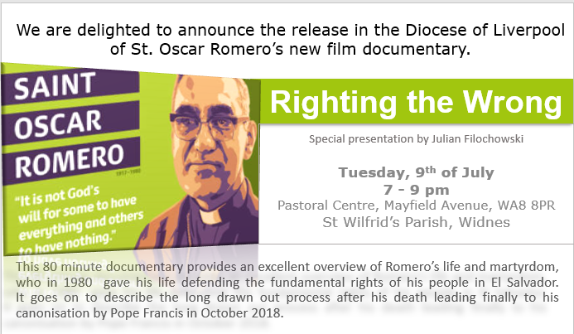

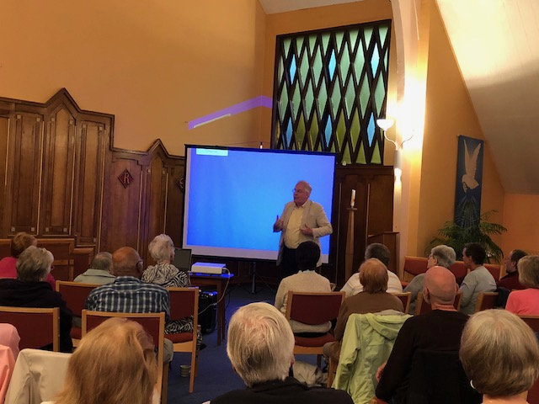

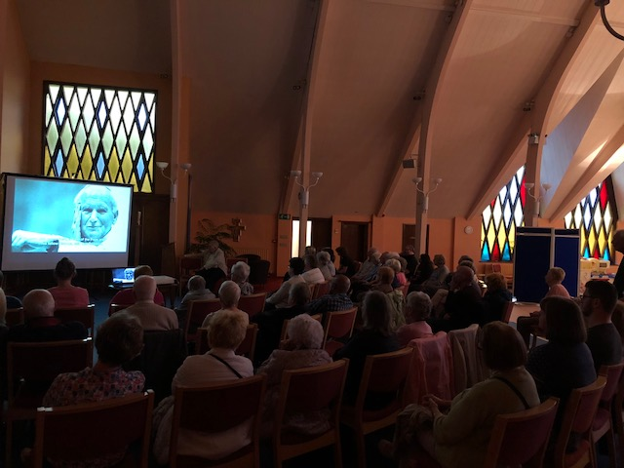

**St Oscar Romero Documentary (Newsletter report)**

On the 9th of July more than 50 people gathered in our Parish Pastoral Centre to watch the latest film documentary about St Oscar Romero's life entitled 'Righting the Wrong'. This 80-minute documentary provides an excellent overview of Romero’s life and martyrdom. It goes on to describe the long drawn out process after his death leading finally to his canonisation by Pope Francis last October.

The film was presented by Julian Filochowski of the Romero Trust who shared his impressions as someone who knew St Oscar Romero and was actively involved in his canonisation process.

For those who couldn't joins us, we are pleased to announce that this documentary is available to watch online: <http://www.romerotrust.org.uk/videos>

There are three additional excellent documentaries to view online about St Oscar Romero and the Church in El Salvador. 'The Last Journey of Oscar Romero', 'El Cielo Abierto' (The Open Sky) and 'Roses in December'.

**Other Action 2: Support CAFOD campaigns**

***First Campaign September/October 2017; ‘Stop the Maua Community Eviction’***. Over 500 signatures were collected and sent off evidencing that “St Wilfrid’s Parish stands with 237 homeless families of the Maua Community in San Paulo, Brazil, who are facing eviction on October 22nd 2017.’

The following excerpt, from December 2017 newsletter, shared some good news:

**This Week’s Reflection**

Wonderful News!

Many of you signed our recent Cafod petition in support of the families in Sao Paulo who were threatened with eviction. The great news is that through the work of the families themselves and indeed the influence of the petition the eviction has been cancelled and indeed there is even greater hope for a more secure future for the families. We often wonder what the effect of signing these petitions are but here is a real example of how they can work and initiate change.

This has been a wonderful early Christmas gift for the families.

Neti de Araújo’s, a leader in the Mauá community, has sent a special message. She says:

***“I want to thank each and every one of you for your support. I am very happy knowing there are people like you, our friends and companions.***

***After so much struggle and sacrifice, ten years of ups and downs, it is finally feasible; we have persuaded the owners of the need for families to live here. The struggle will continue! Thank you!”***

CAFOD will continue to stand in solidarity and pray for the families in their struggle for a safe and permanent home.

Fr. Michael

**Second Campaign June 2019; CAFOD Climate Change Mass Lobby…. (See newsletter insert below)**

**CAFOD Climate Change Mass Lobby**: On Wednesday 26th June CAFOD are hosting a mass lobby outside of parliament to give a loud message to leaders that climate change is an important issue and that the time for change is NOW. A group will be travelling down to represent Widnes and St. Wilfrid’s parish, to send the message that we care and that we want to see change.

The effects of climate change are not the horror stories of a potential future, they are happening now and they are affecting some of the world poorest people with droughts and extreme weather events, amongst many other negative changes.

**Petition:** Next weekend there will be a petition to sign at the back of church where you will be able to show your support for the campaign. Fr. Mike and our parishioners will then take this petition to parliament and, hopefully, present it to Derek Twigg, our MP, to show him that this is an issue that his constituents care about.

**Sending Mass:** On Saturday evening please join us for our Sending Mass where there will also be an opportunity to hear from ***CAFOD’s Jose Batista*** ***Alfonso*** who will speak about the work done in Brazil. There will also be an opportunity to meet Batista after Mass, sharing tea and coffee.

**Contact Derek Twigg MP**: Another way that you can show your support would be to email or write to Derek Twigg MP to tell him that the environment and climate change is something that is important to you. Email: derek.twigg.mp@parliament.uk Address: Derek Twigg MP, House of Commons, London, SW1A 0AA.

***Let’s make a difference for the sake of the poorest communities who are suffering now, as well as for our future generations, so that we can say that we were part of making a positive difference for our planet.***

We created a petition which got over 600 signatures for Eco Mass Lobby in London and a group of Parishioners travelled down to London to support the campaign.

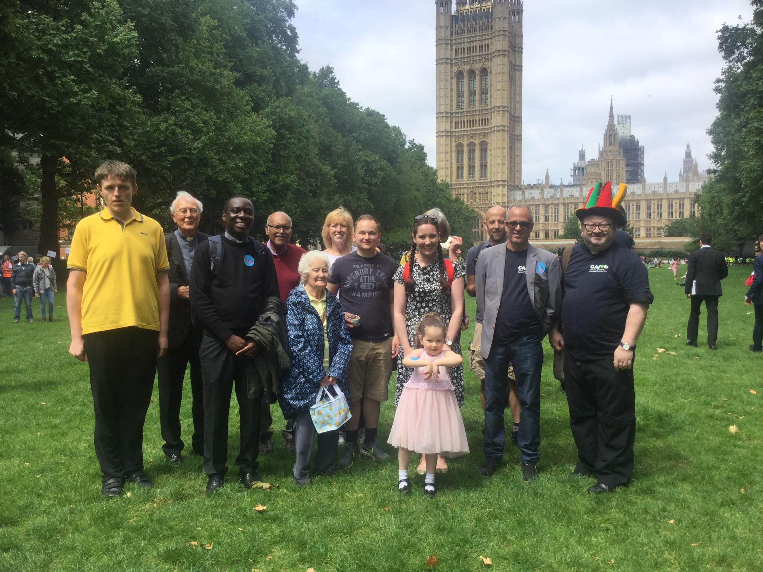

Pictured above are the parishioners and priests with ***CAFOD’s Jose Batista*** ***Alfonso*** who had spoken at the Mass of Sending in the Parish.



The **CAFOD Climate Change Mass** **Lobby** was a brilliant, action packed day. It began with a procession from Trafalgar Square to Church House. There were signs held high, chanting, and a great air of excitement. There were **16,000** people at the event, but luckily we had Bishop John and Fr. Anthony leading the way with Fr. Michael and his multi-coloured hat to follow!

This was followed by an inspiring multi-faith talk involving several faith leaders which gave us lots to think about. We then moved to outside of parliament where everybody had alarm clocks set to 2pm, with thousands of alarm clocks sounding at once.

These are a few of the quotes from faith leaders during the day which we found particularly inspiring:

• **Damaging the world that we are living in is like “Sawing the branch we are sitting on”**

**• “Let us take a moment to breath in the air, the air that we all share”**

**• “The environment and the air that we breath has no faith”**

**• “We have heard from people of all different faiths, and yet everybody is in agreement about the need to take action for our common home”**

**“But do we have the integrity to do it?”**