**Living Simply**

**Main Action; Live Simply newsletters column**: (Established Autumn 2017) We have an ongoing Column in the weekly newsletter dedicated to eco tips and messages of solidarity for those around the world.

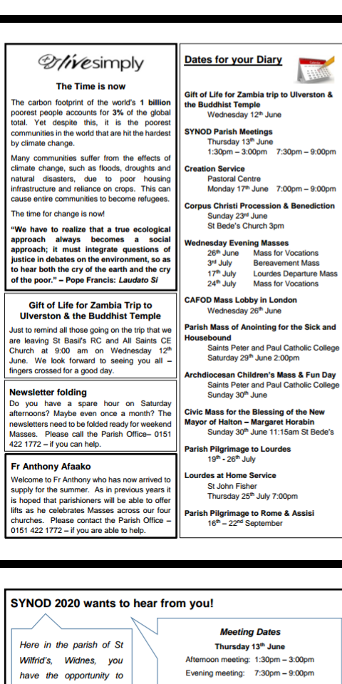

**Other Action 1; Livesimply Christmas Event**

**Christmas Event –** We hosted a Christmas event at the Parish Pastoral centre which involved stalls from local charities, Fairtrade products to try.

Christmas Messy Church – This included simple crafts, in opposition to the media fuelled frenzy of excessive and unnecessary spending on Christmas time on decorations and Christmas activities. The event was free on charge and involved a free grotto, Christingle service and a focus on the simple, true meaning and spirit of Christmas.

**Christmas Event!**

Come along to the

*Live Simply*

Christmas event



Come along to our Live Simply Christmas Coffee Morning

***10:00am -12 noon***

***Friday 24th November***

***Pastoral Centre***

Good cakes, refreshments, charity Christmas cards and crafts on sale, Christmas music and good cheer for all ages.



**Christmas Cards**

As part of being a ‘Live Simply’ parish, finding ways to help charities is a great way of being in **solidarity** with those in need.

At the back of each church from next weekend until Christmas you will find Christmas cards for sale from:

* **Cafod**
* **Medialle Trust**
* **Nugent Care**
* **Papyrus**
* **Carmelite Monastery**

They can also be bought at various groups in the parish such as tots group.

Share Christmas greetings with each other, while sharing the love associated with this special time to those who need it most.

**Christmas Event**

To help support being a *livesimply* Parish we are considering arranging a Christmas celebration event.

There will be a gathering on:

**Thursday 9th November**

**7:00pm**

**St Bede’s Presbytery**

Everybody welcome!

**Other Action 2; CAFOD inspired ‘Lenten Fast’ Soup evening;** **March 2019**

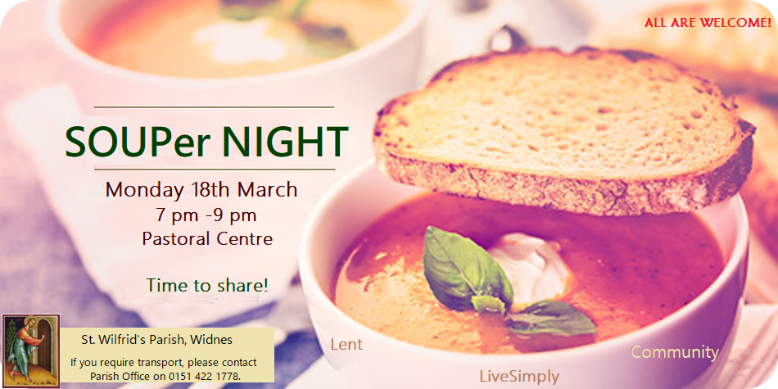

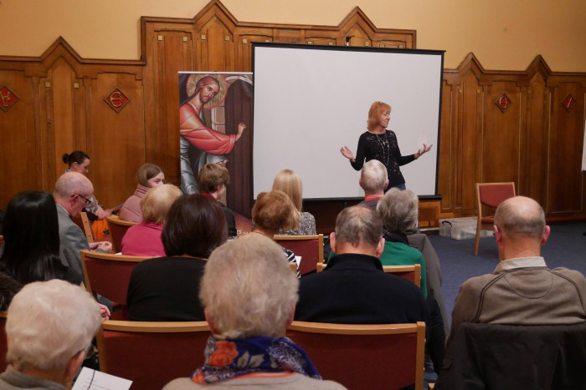 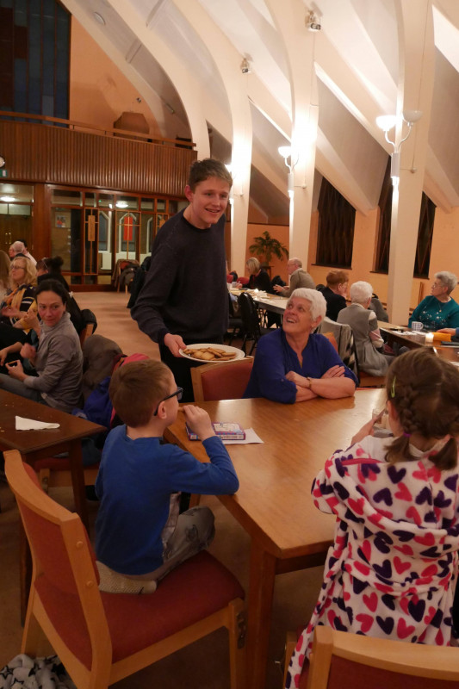

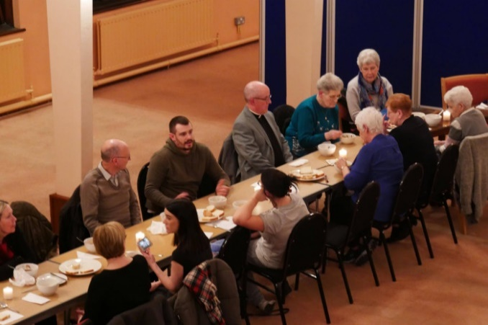 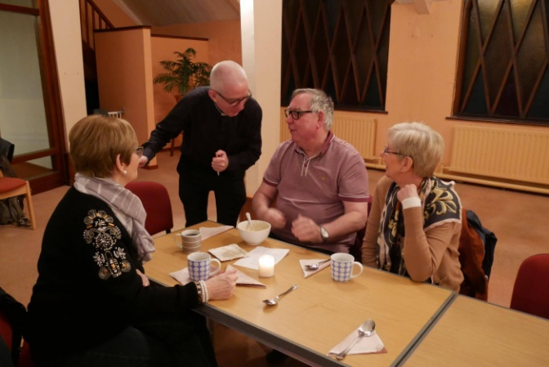

**Live Simply - soup evening (newsletter report)**

To support our Live Simply initiative and also to gather together as a Parish Community a 'Souper evening' was held at the Pastoral Centre on Monday 18th March. It was linked to how we consider the CAFOD Family Fast as a community; how we can Live Simply; but importantly to build on the gatherings we have for tea and coffee after several Masses in all of our churches as a community together.

It was a wonderful evening that was attended by 54 people, aged from 8 years through to 85! It was a time to gather, share soup, break bread together and also to share ourselves in terms of conversation and fun. It was good to see families sharing games and conversation with other people and 'listening to each other'. The soup was prepared from 'scratch' across a number of parishioners’ kitchens, catering for every taste, with a wide variety of breads donated. Skills were variable in the games of Jenga, cards, dominoes etc.

The evening was held by candlelight to reduce electricity; resources were minimal with absolutely no waste! People were asked to feedback on three 3 questions via anonymous post-its: What did you think of the evening? If you would like to repeat this what would you like to do? How often would you like to do this? 35 responses were received with the most common response being 'excellent evening'. Others consisted of:

‘It was good meeting new people and some whom I recognise from church but don't know their names’;

*‘Soup was amazing and it was good company’;*

*‘A great gathering of community’;*

*‘Soup and bread was a lovely start what about Live Simply around the world?’;*

*‘Lovely to see young families’;*

*‘Lovely to see a mix of all ages joining together and enjoying simple things’;*

*‘Fr Carl needs to improve his Jenga skills’;*

*‘Relaxed evening and welcoming’;*

*‘As a non-Catholic I was made to feel very welcome’;*

*‘Everything was outstanding, a real triumph!’*

Most people suggested repeating this on a 3-month basis particularly around CAFOD Family Fast times in Lent and Harvest. Ideas where a shared table with foods from the world; Summer strawberry scones/tea; quiz night; soup at Harvest.

Another evening is planned for Monday 17th June 2019 - 'homemade strawberry scones!' All welcome.